Kingdom of Saudi Arabia
Majmaah University
College of computer and information sciences


Assignment 1

CS 473

NAME: Ziad Othman Al-Abduljabbar

ID: 441100931

Assignment 1- CS 473 (Submission Date- within 1 week)

- Discuss R Studio Interface with screenshots from your system.
• Q1: Files, Plots, Packages, Help, Viewer
• Q2: Environment, History, Connections
• Q3: Source (scripts, datasets)
• Q4: Console, Terminal
Files pan Q1:
The Files pane works like a file explorer, just like Windows Explorer on a Windows computer. It helps you manage your files and folders in RStudio. Here’s what you can do with it:
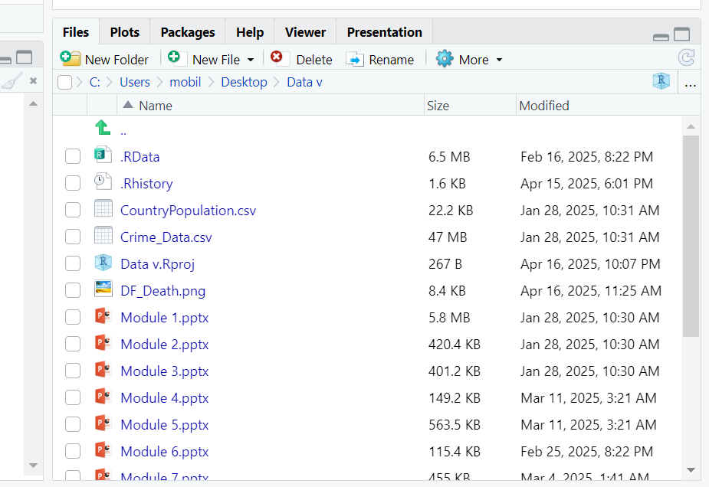

- Delete files and folders
- Create new folders
- Rename folders
- Move between different folders
- Copy or move files to other places
- Set or go to the working directory
- Open and view files
- Import datasets into RStudio
Plots pan Q1:
is used to show graphs and charts that are created when you type code in the Console or run a script. You can make these plots using different R packages.

Viewer Pane Q1
The Viewer pane is used to display local web content, like interactive charts or web pages created with packages such as googleVis, htmlwidgets, or Shiny.

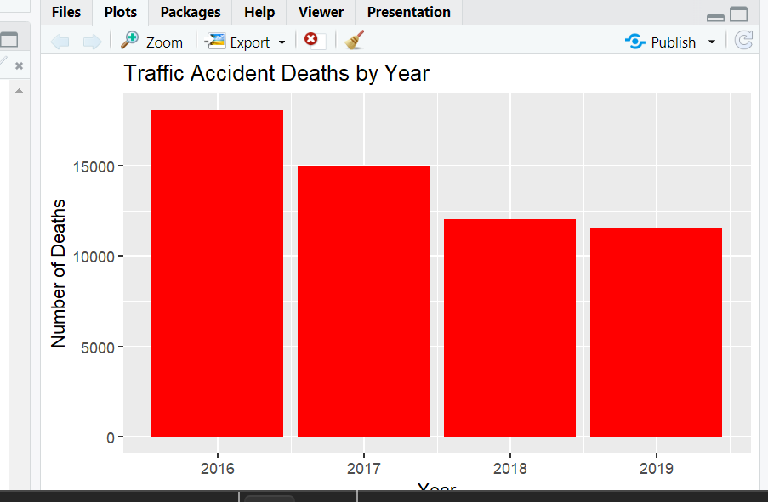
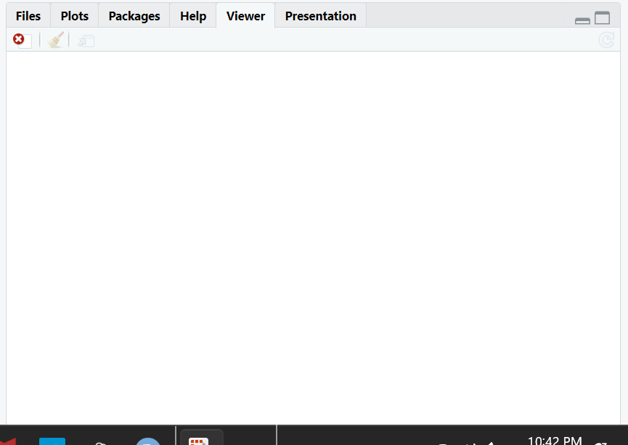

Packages Pane Q1
The Packages pane shows a list of all the packages that are currently installed, along with a short description and their version number.
- You can remove a package by clicking the “x” next to its version number.
- If you click on the package name, it will open the help file in the Help tab.
- To use a package in your code, check the box next to its name. This loads the package so you can use its functions in the Console.
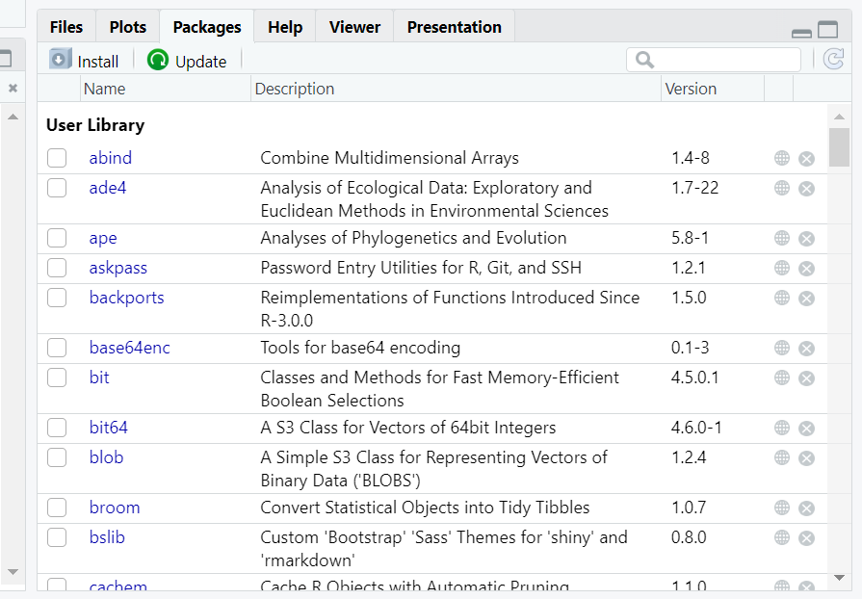
Help Pane Q1
The Help pane shows the documentation for R functions, packages, and commands.
If you click on a package name or use the ?function_name command in the Console (like ?mean), the Help pane will display details about how to use that function or package, including examples and explanations.
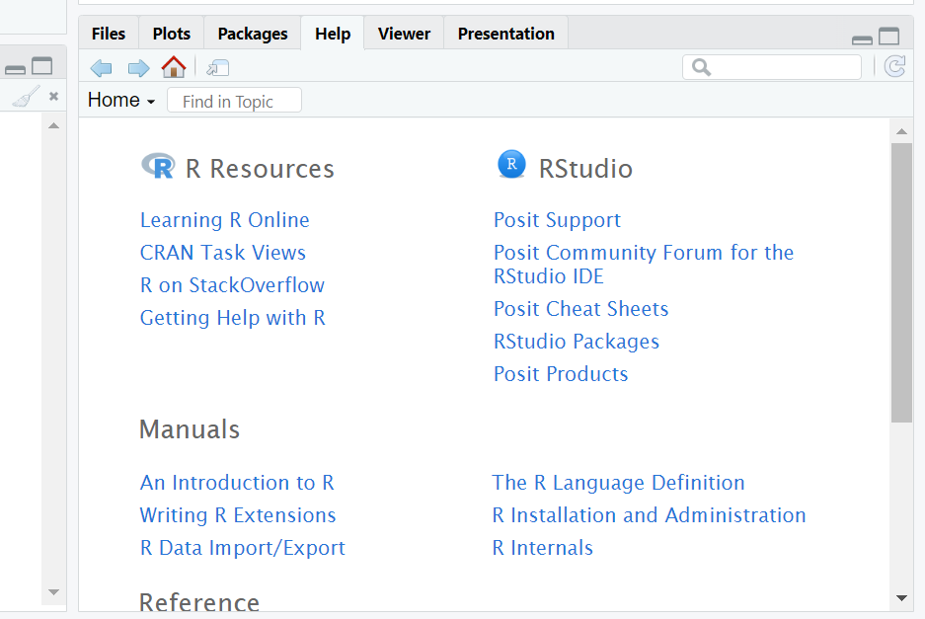

Environment Pane Q2
The Environment pane shows all the variables you’ve created during your current R session.
Each variable is listed, and you can click on it to see its contents.
If you click the small table icon on the right side of a variable, it will open the data in a table format, making it easy to view and explore.
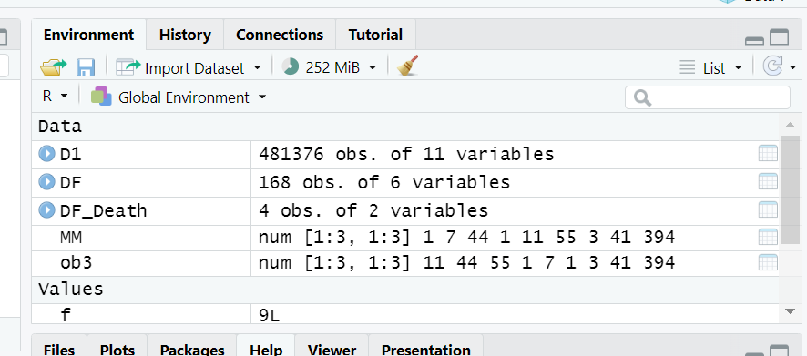
History Pane Q2
The History pane shows a list of all the commands you've run in your current R session.
WE can:
- Select commands and send them back to the Console or into a script.
- Delete commands from the history if you don’t need them anymore.
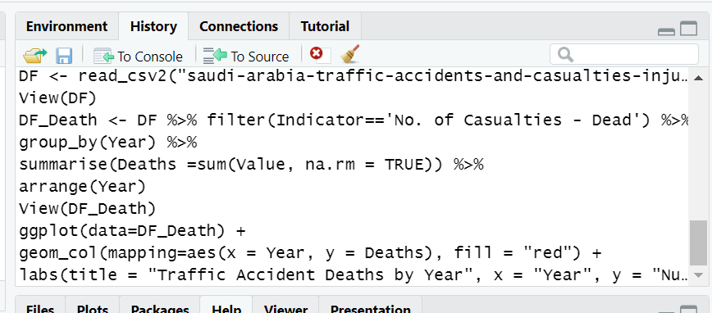

Connections Pane Q2
The Connections pane lets you connect to data sources like ODBC or Spark.
You can use it to open existing connections or create new ones, making it easier to work with external databases directly from RStudio.

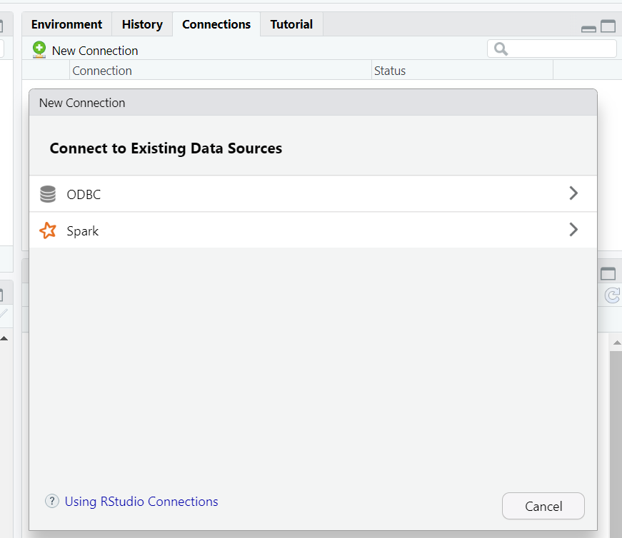

Source Pane Q3
The Source pane in RStudio, shown below, is where you create scripts and view datasets. An R script is a text file with commands that run together.
You can also type commands directly in the Console pane, where each line runs when you press Enter. But scripts run all at once.
You can open multiple scripts at the same time, each in its own tab, as shown below.
RStudio lets you run the whole script, just one line, or a selected part of the script, giving you control over how the code runs.
The Source pane can also display datasets, like the data frame shown below.
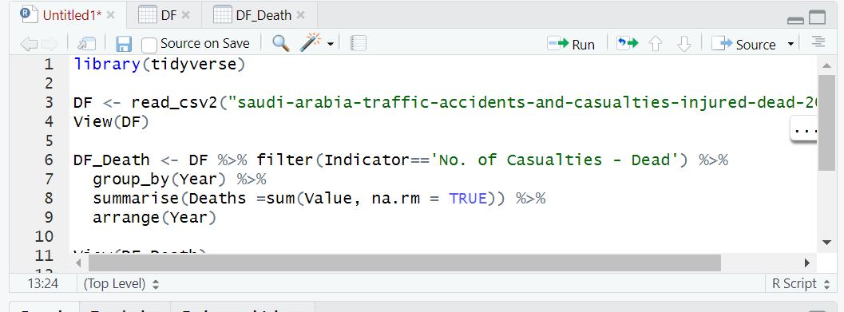
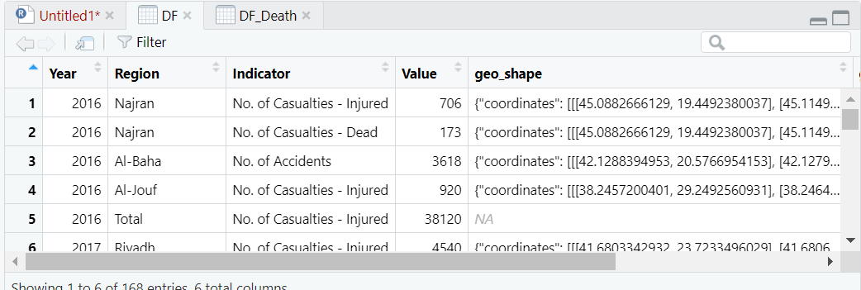
Console Pane Q4
The Console pane is used to write and run code interactively.
Each time you type a line of code and press Enter (Return), it will execute that line.
Any warning or error messages, along with output from print() statements, will appear in the Console window.
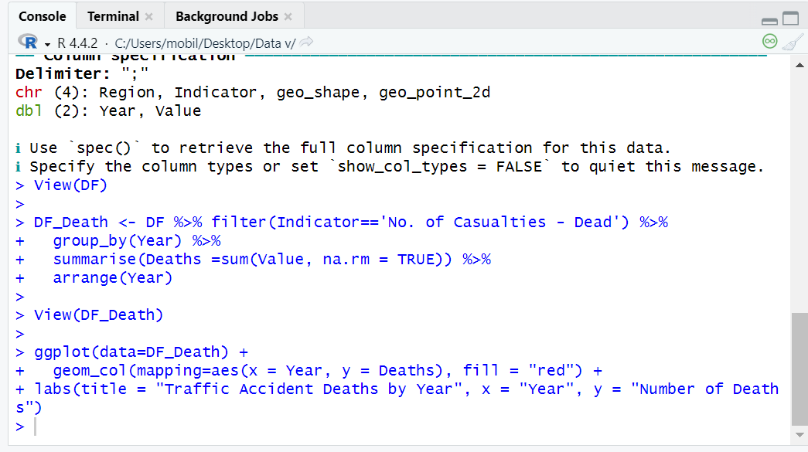
Terminal Pane Q4
The RStudio Terminal pane lets you access the system shell inside RStudio.
It supports xterm emulation, so you can use full-screen terminal apps (like text editors) and perform regular command-line tasks with line editing and shell history.
You can use the terminal for things like source control, running long jobs, remote logins, and system admin tasks.
The Terminal pane works differently depending on the platform, with specific features for Windows or other systems like Mac, Linux, or RStudio Server.
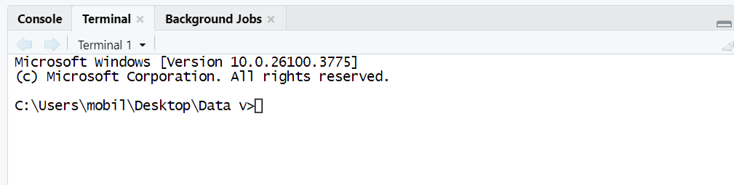
- How you can customize R studio interface, also submit screenshots from your system.
We can customize the interface by:
- Going to Tool | Options (RStudio | Preferences)
- Use the Pane Layout tab to change pane positions and tabs
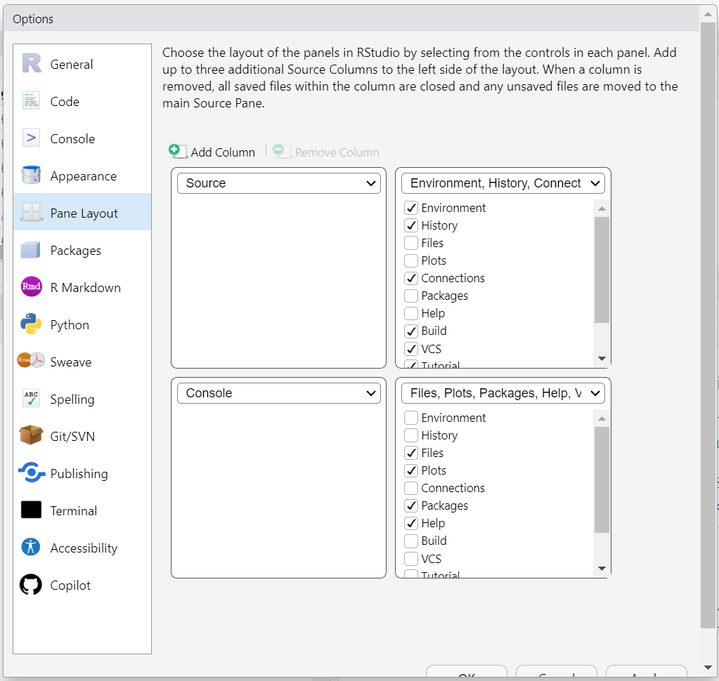
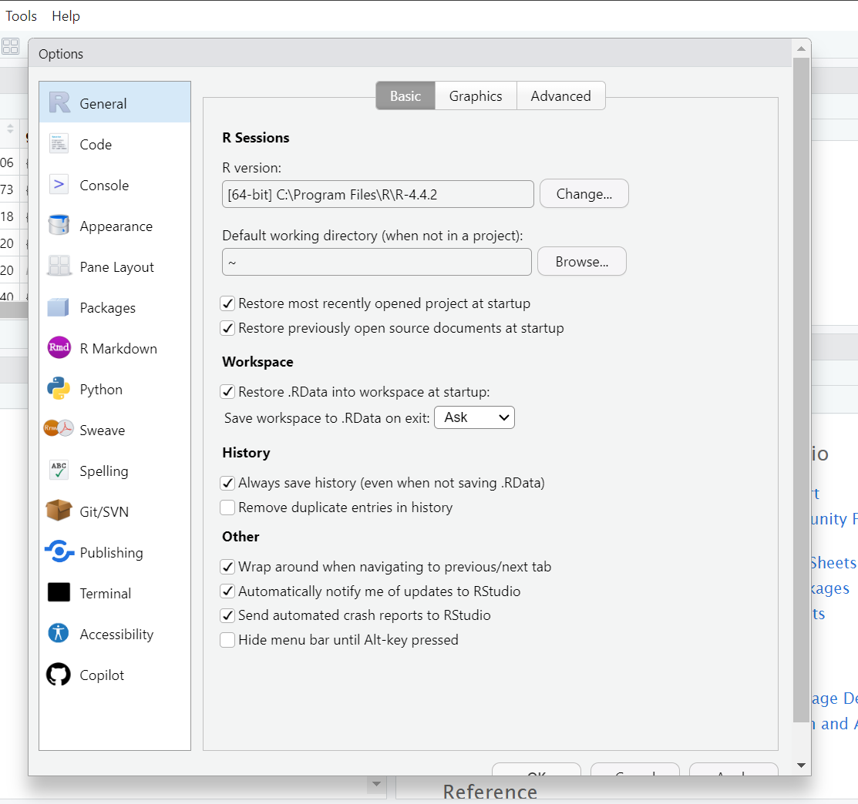

- How to see all variables in R Studio.
We can see all variables by:
- Environment pan
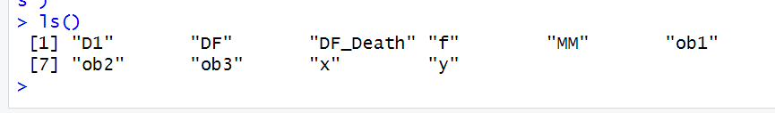
- Use ls() function

- Describe vectors and factors and also provide the code.
Vector is a sequence of the same type of data elements, use c() function to put sequence of elements
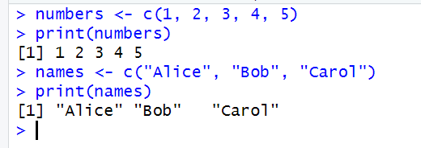
Factor is basically a vector but with categories
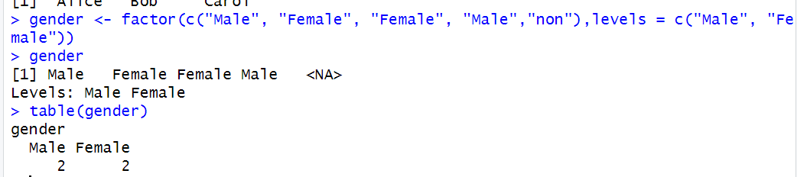
- Describe the list function with code.
Lists can contain different types and others lists, use list () function
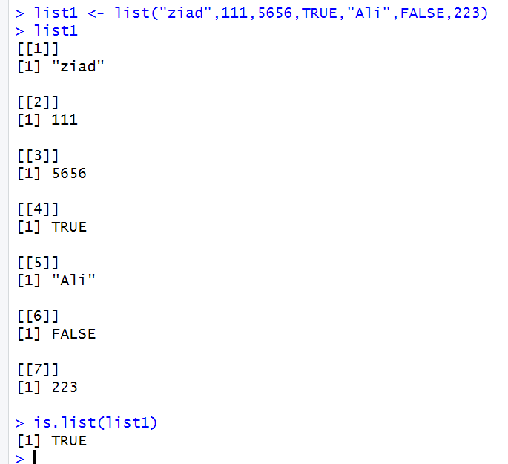
- Describe the data classes with code.
Matrix same data type with multidimensional, use matrix () function that contain element by use c () and number of rows and columns

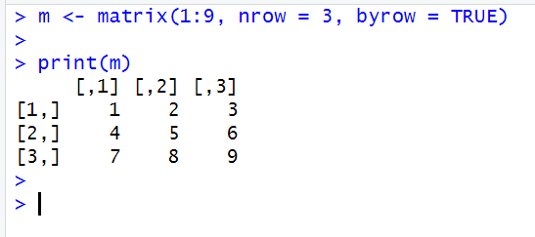

Data Frame same matrix but it can store mixed types
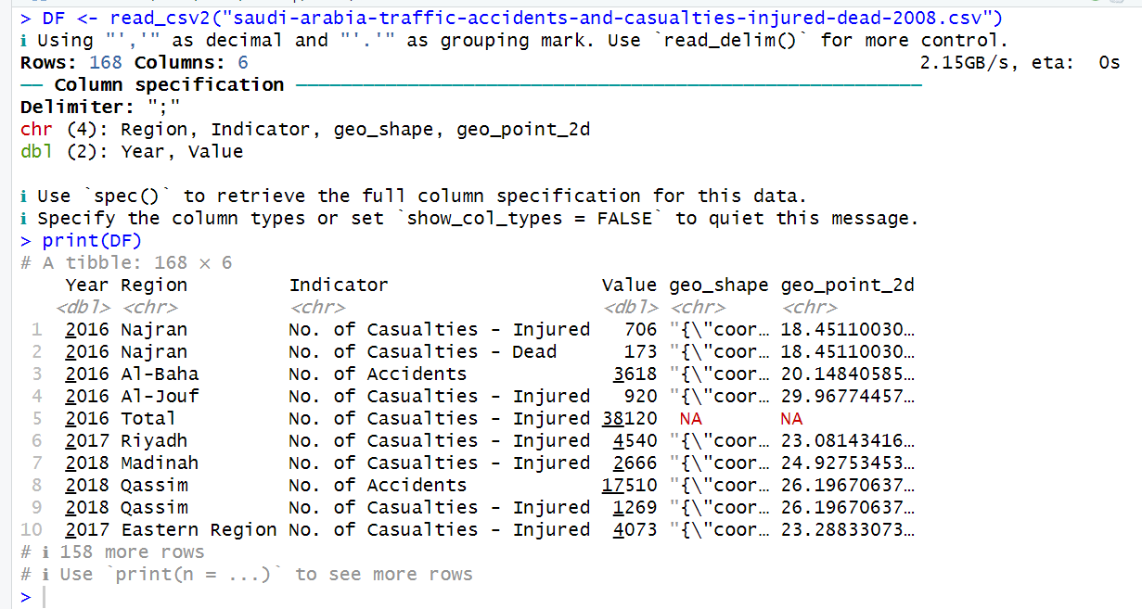

- Show looping and decision support statements.
Looping:
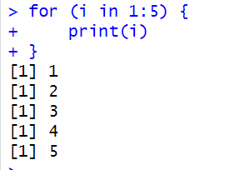

decision support statements:
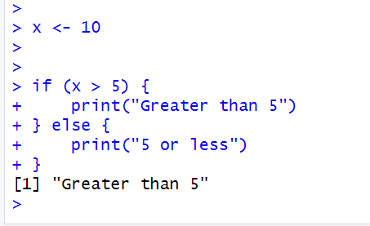

- Take a sample of 9 students for any 3 subjects, demonstrate the use of built functions for basic statistics using R studio.
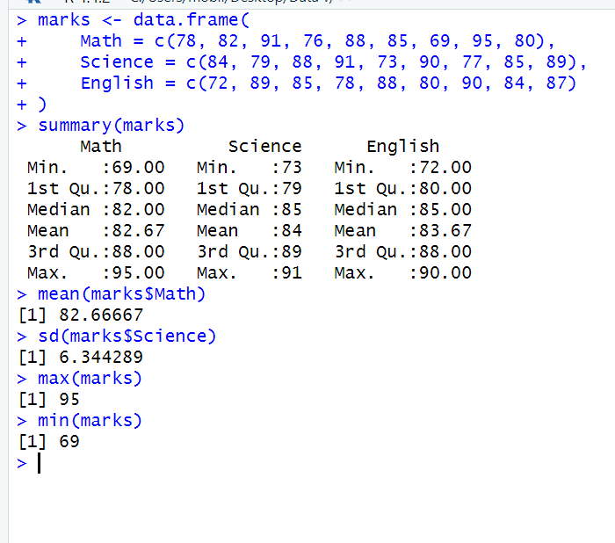
- Describe the tidyverse and major packages of tidyverse.
The tidyverse supports a comprehensive data science workflow as illustrated in the diagram below
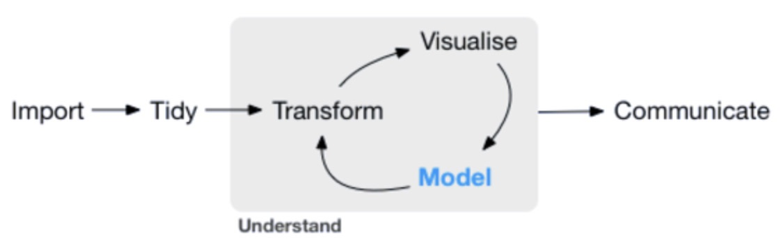
- readr – The goal of it to facilitate the import of file-based data into a structured data format contains 7 functions

- dplyr – is a very important part of tidyverse. It includes five key
functions for transforming your data in various ways, contains filter(), arrange(), select(), mutate(), and summarize() and work together with group_by()

- tidyr – Data tidying is a consistent way of organizing data in R, and can be facilitated
through the tidyr package. There are three rules that we can follow to make a
dataset tidy. First, each variable must have its own column. Second, each
observation must have its own row, and finally, each value must have its own
cell.

- ggplot2 – The building blocks used in ggplot2 to implement the Grammar of Graphics include data, aesthetic mapping, geometric objects, statistical transformations, scales, coordinate systems, position adjustments, and faceting

- tibble – Modern data frame

- lubridate – Dates and times
All work together seamlessly.

- Write a code to load, examining and filter data using tidyverse in R Studio
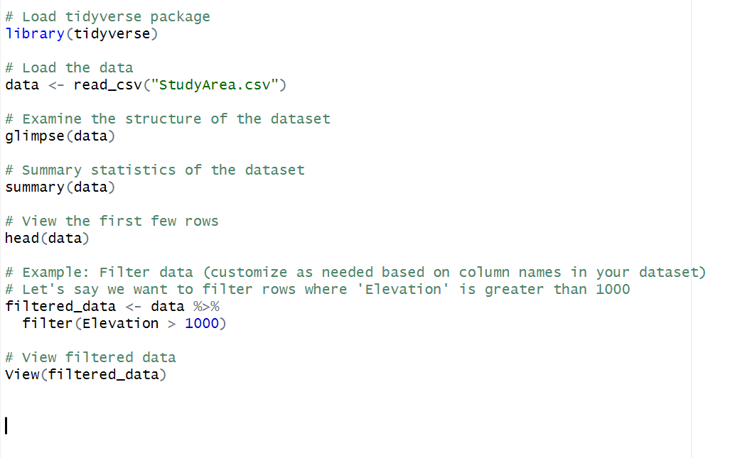
NOTE: IF TWO ASSIGNMENTS ARE SAME BOTH GET ZERO (0)MARKS

